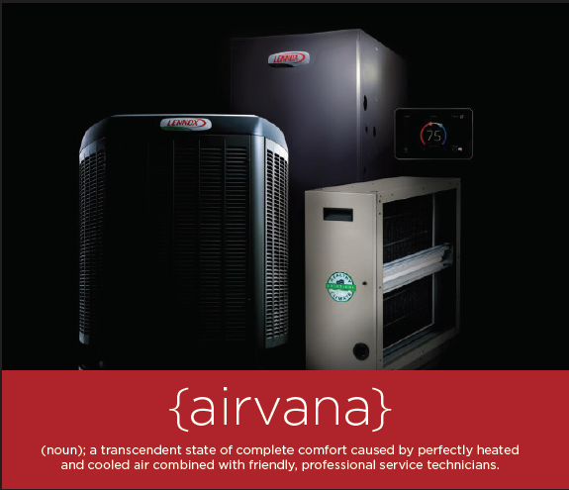

Every Lennox® product has been engineered to deliver best-in-class comfort and efficiency. And when two or more Lennox products are working together as part of a system, the results are truly outstanding. Whatever your home, lifestyle and budget, there’s a Lennox system that can meet your needs. Call today and save with **REBATES UP TO $1,700* *OR* UP TO 72 MONTHS INTEREST-FREE FINANCING on qualifying equipment.**

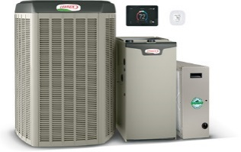**START WITH UP TO $1,300 IN REBATES.\***

Save on a complete qualifying Lennox® home comfort system that includes a gas furnace or blower coil, an air conditioner or heat pump and thermostat. Enjoy additional product rebates when you purchase an iComfort® S30 Smart thermostat, iHarmony ® zoning and a PureAir™ system.

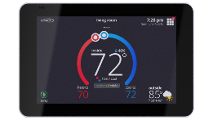**GET UP TO A $150 REBATE ON a WI-FI THERMOSTAT.\***

**OR,** A LIMITED-TIME **FINANCING OFFER**

**Up to 72 MONTHS, INTEREST-FREE FINANCING\*\***

Save now on the iComfort® S30 and save every month on utility bills. Anytime

your routine or weather changes, the iComfort S30 smartly adapts to reduce

your energy costs.

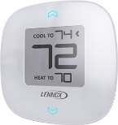

**GET UP TO A $100 REBATE ON ZONING.\***

Enhance your comfort and savings with iHarmony® zoning,

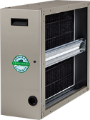a major advance in precision climate control.

**GET UP TO A $150 REBATE ON pUREAIR™.\***

Enjoy more savings and fewer pollutants with a PureAir™ system, which cleans

the air inside your home better than any other single system you can buy.

Top of Form

**Get comfortable now & CALL for details.**

Bottom of Form

*Some restrictions apply. System rebate offers range from $150–$1,700. Rebate offer is **valid March 12, 2018 through June 15, 2018** with the purchase of qualifying Lennox products. Cannot be combined with any other offer. Additional add–on rebates for iComfort® S30 Thermostat, iHarmony® Zoning System and PureAir™ Air Purification system valid with a qualifying system purchase only. See your participating Lennox dealer for complete details.

**Financing available to well qualified buyers on approved credit at an 0% APR for 72 months, with equal monthly payments. You may prepay your account at any time without penalty. Financing is subject to credit requirements and satisfactory completion of finance documents. Any finance terms advertised are estimates only. Normal late charges apply. See your Truth in Lending Disclosures for more information.